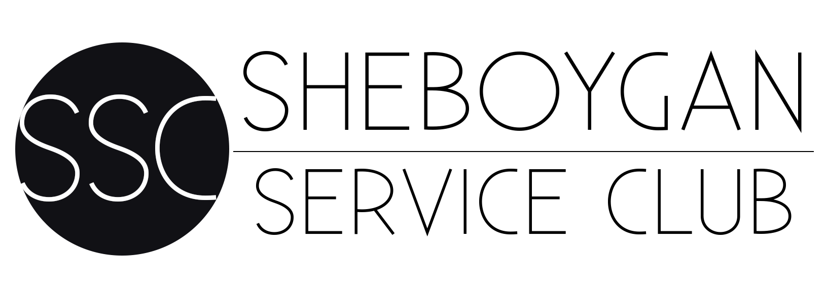
SHEBOYGAN SERVICE FOUNDATION, INC
2020 PARTNER CHARITY APPLICATION

Submission and any accompanying materials must be e-mailed
by March 31, 2020 to:

SheboyganServiceClub1931@gmail.com

Sheboygan Service Foundation endeavours to foster interest in its members in the social, economic, educational, cultural, and civic conditions of Sheboygan County and to prepare members for continuing volunteer service within their community. We have a proud history rooted in the belief that a group of women can give a powerful witness to charity and social justice.

Organization Name: ___________________________________________________________

Organization’s Director/Title: ___________________________________________________
Address: ____________________________________________________________________

City, ST, Zip: ______________________________ County: _______________________

Phone Number: _____________________ Fax Number: __________________

Website: ____________________________________________________________________

Email: _______________________________________________________________________

*FEIN#: ______________________ *Applying organizations must have 501(c)(3)status.

Date of Incorporation: ______________________ Organization Fiscal Year: ___________

Nature of Request (including project or program name): _______________________________

Amount Requested (minimum $50,000): __________________________
For any questions SSC may have pertaining to this funding application, please contact:

Application Contact/Title: ________________________________________________________

Application Contact Phone Number: _______________________________________________

I. ORGANIZATION INFORMATION

1. Provide your organization’s vision and mission:

2. Description of current programs and activities:

3. Number of persons served annually:

4. What are two of your organization’s most recent accomplishments?

II. FUNDING REQUEST
1. Describe the program or project, including a statement of needs/problems to be addressed and description of how Sheboygan County communities will benefit.

2. What are three goals you wish to accomplish with this funding?

3. How many participants will be served through this project or program?

4. List any other actual or potential sources of funding for the program/project.

5. How will you sustain your program/project financially in the future?

III. FINANCIAL INFORMATION

1. Attach organization’s 2019 and 2020 annual budget.

2. Attach Program/Project Budget (if applicable).

3. Statement regarding the organization’s audit procedures.

4. What percentage of your organization’s revenue comes from the following sources?
State/federal grants _____
Earned Income _____
Donations _____
Other _____

5. If you have received funds from SSF in the past, describe how those funds were utilized.

IV. EVALUATION

1. What are your plans for monitoring and evaluating success?

2. If chosen as the 2020 Partner Charity do you agree to (Please answer yes or no):
- Present on your progress with the project/program at our Annual Meeting in June 2021? _____

- Provide a Year End report for 2021? _____

- Avoid any fundraising appeals between September 1, 2020 and December 1, 2020? _____

- Actively promote the Sheboygan Service Club throughout 2020 and give specific mention of the contributions of SSC and your partner charity status in your social media, website, mailings and fundraiser appeals? ______

V. ATTACHMENTS

The following attachments must be included in all Funding Applications:

1. A copy of FEIN.

2. A copy of the current IRS determination letter indicating 501(c)(3) status.

3. Listing of Board of Directors

PARTNER CHARITY AGREEMENT
The chosen partner charity will be expected to perform supporting duties to promote the Charity Ball, being held November 7, 2020. The chosen partner will be viewed as an extension of the Sheboygan Service Club by actively engaging in the following:

1. Actively promoting the Charity Ball in the community, within the partner organization (board of director, mailing lists, social media, website, previous benefactors, etc.).
2. Selling a minimum of 50 raffle tickets.
3. Providing auction items that have a minimum value of $1,000.00.
4. Securing ticket sales to fill a minimum of two corporate level tables the night of the Charity Ball.
5. Suspending any other solicitation of funds outside of the Charity Ball form September 1, 2020 through December 1, 2020.

If selected as Partner Charity, you are not eligible to apply again as Partner Charity for six (6) years. You are encouraged to apply for SSC General Funding annually.

By completing this application you agree to the above listed expectations and understand that the amount of funds raised depends wholly upon the partnership between SSF and your organization.

Has the organization’s Director authorized this request? ___ Yes ___ No

The undersigned, an authorized officer of the organization, does hereby certify that the information set forth in this funding application is true and correct, that the federal tax exemption determination letter attached hereto has not been revoked and the present operation of the organization and its current sources of support are not inconsistent with the organization’s continuing tax exempt classification as set forth in such determination letter. I further agree to utilize any funding received specifically for the purpose as stated above.

X ____________________________________________________________________________
Signature Print Name/Title Date

